Final Term Project

1. Creating a virtual environment so that we can install django and other packages in the same environment.

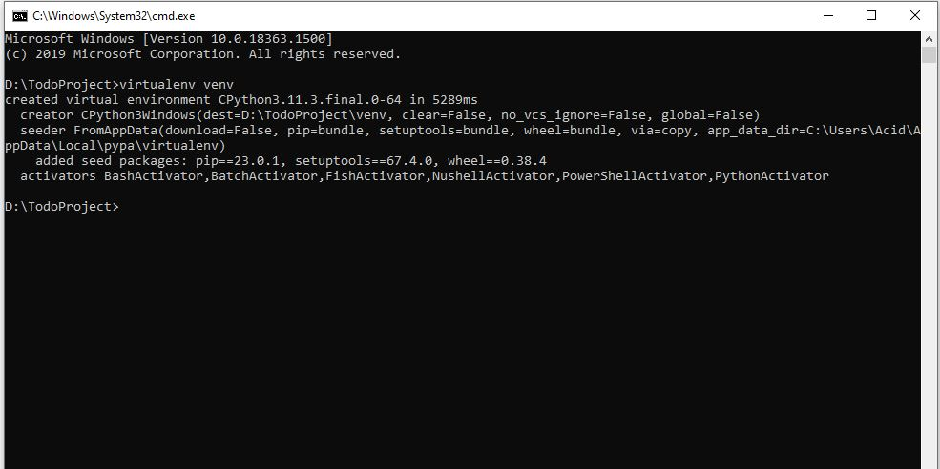

1. After activating the environment so that we can work on that

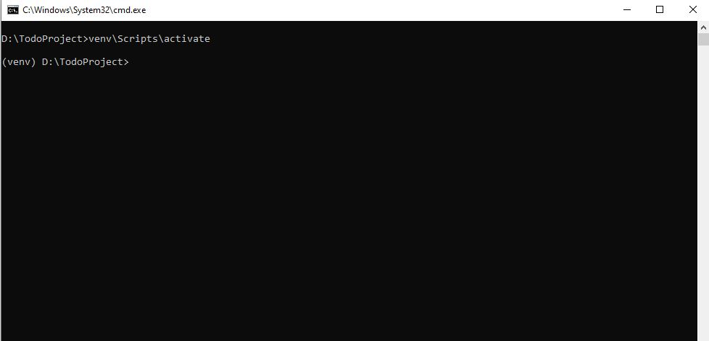

1. Installing django latest version using pip command.

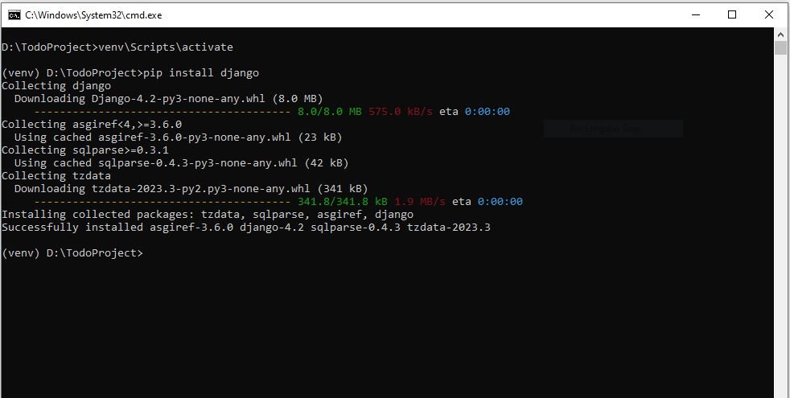

1. Starting django project using django-admin command.

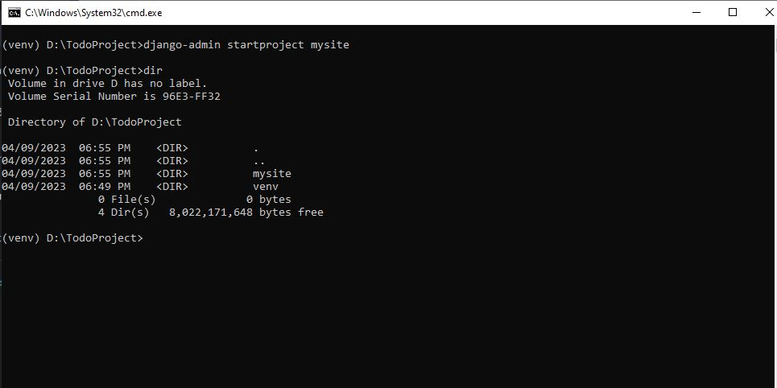

1. Starting out TODO app

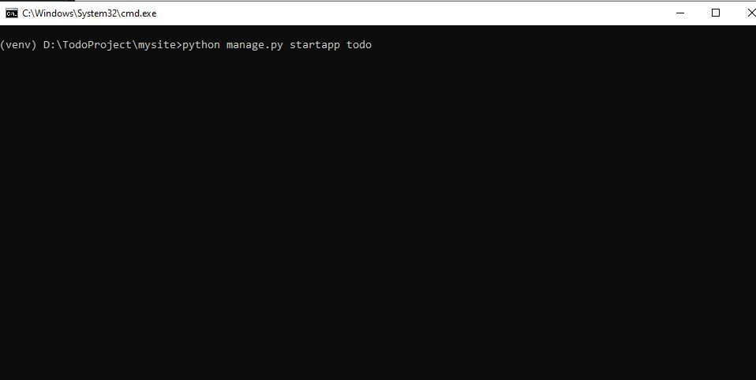

1. After writing our models then we are migrating our database using makemigrations and migrate command

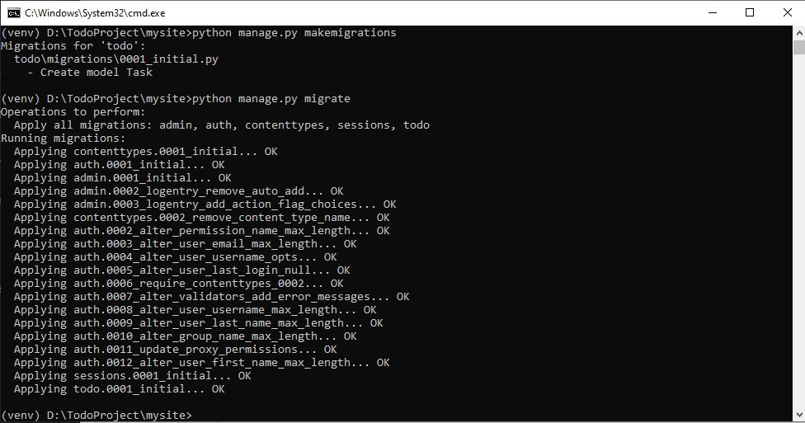

1. Finally we are creating a superuser to access the admin database in our case username is “admin” and password is also “admin”.

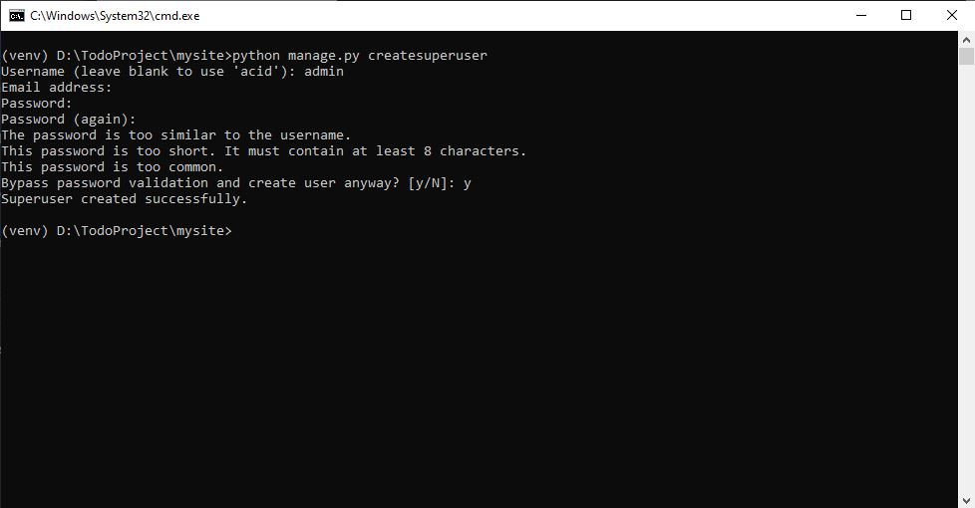

**Models.py file code:**

from django.db import models

class Task(models.Model):

title = models.CharField(max_length=200)

description = models.TextField()

due_date = models.DateField()

priority = models.IntegerField(choices=((1, 'Low'), (2, 'Medium'), (3, 'High')))

completed = models.BooleanField(default=False)

created_at = models.DateTimeField(auto_now_add=True)

updated_at = models.DateTimeField(auto_now=True)

def __str__(self):

return self.title

**Views.py file code:**

from django.shortcuts import render, get_object_or_404, redirect

from .models import Task

from .forms import TaskForm

def task_list(request):

tasks = Task.objects.all()

return render(request, 'task_list.html', {'tasks': tasks})

def task_detail(request, pk):

task = get_object_or_404(Task, pk=pk)

return render(request, 'task_detail.html', {'task': task})

def task_create(request):

if request.method == 'POST':

form = TaskForm(request.POST)

if form.is_valid():

task = form.save(commit=False)

task.save()

return redirect('task_detail', pk=task.pk)

else:

form = TaskForm()

return render(request, 'task_create.html', {'form': form})

def task_update(request, pk):

task = get_object_or_404(Task, pk=pk)

if request.method == 'POST':

form = TaskForm(request.POST, instance=task)

if form.is_valid():

task = form.save(commit=False)

task.save()

return redirect('task_detail', pk=task.pk)

else:

form = TaskForm(instance=task)

return render(request, 'task_update.html', {'form': form})

def task_delete(request, pk):

task = get_object_or_404(Task, pk=pk)

if request.method == 'POST':

task.delete()

return redirect('task_list')

return render(request, 'task_delete.html', {'task': task})

**Urls.py file code:**

from django.urls import path

from . import views

urlpatterns = [

path('', views.task_list, name='task_list'),

path('task/<int:pk>/', views.task_detail, name='task_detail'),

path('task/new/', views.task_create, name='task_create'),

path('task/<int:pk>/edit/', views.task_update, name='task_update'),

path('task/<int:pk>/delete/', views.task_delete, name='task_delete'),

]

**Forms.py file code:**

from django import forms

from .models import Task

class TaskForm(forms.ModelForm):

class Meta:

model = Task

fields = ('title', 'description', 'due_date', 'priority', 'completed')

widgets = {

'due_date': forms.DateInput(attrs={'type': 'date'})

}

**How to run project:**

First open the main “todoproject” folder in terminal. Cd todoproject.

Then “venv\Scripts\activate”

Then “cd mysite”

Then “python manage.py runserver”

**Screenshot of all pages:**

Home page visit <http://127.0.0.1:8000/todo> . This is the home page where you can create, view edit task.

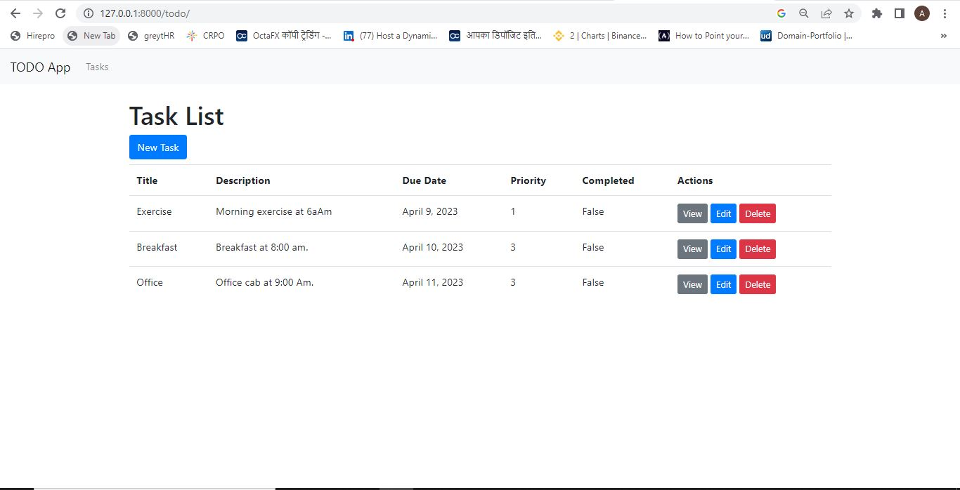

**Create Task:**

If you click on the new task button then this will load a form to create new task.

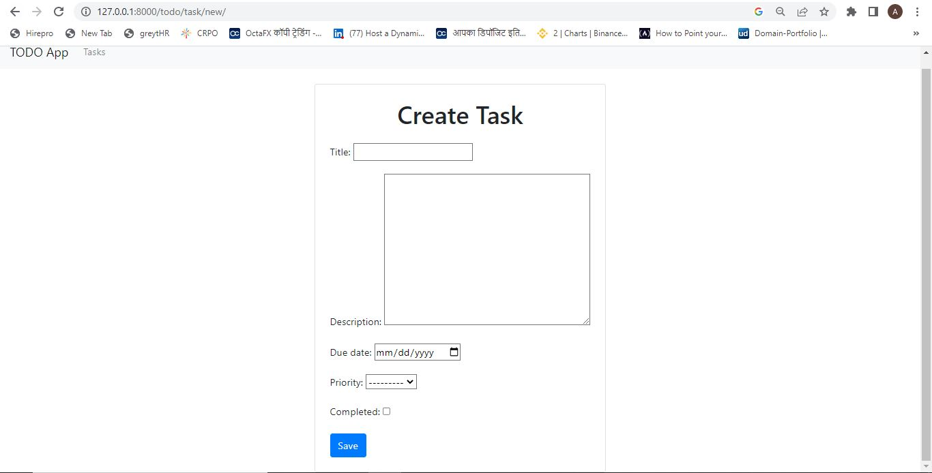

**View Task :**

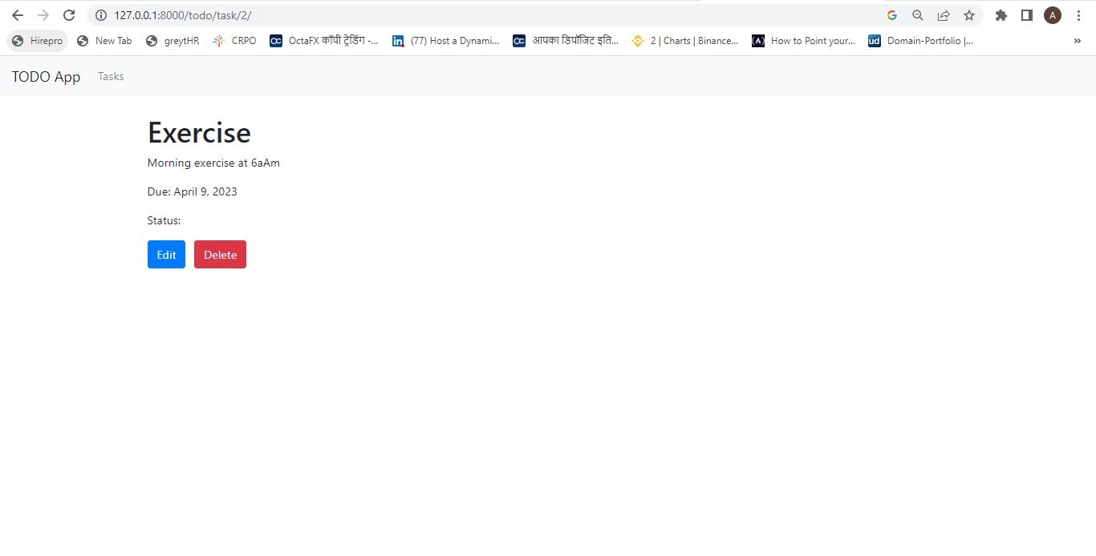

**Edit Task:**

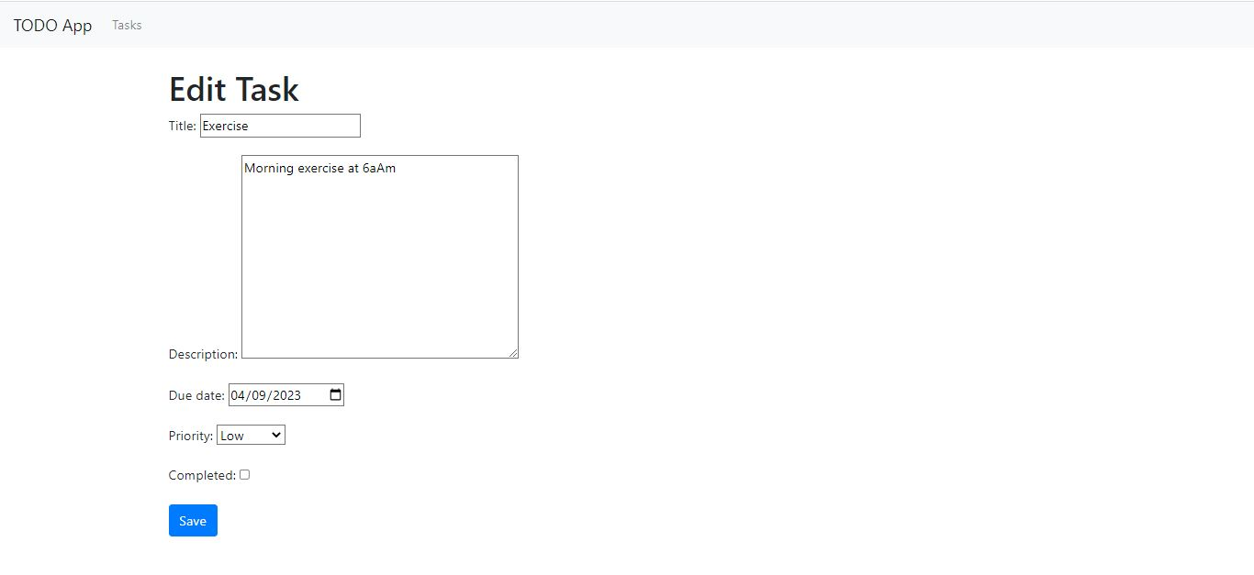

**Delete Task:**

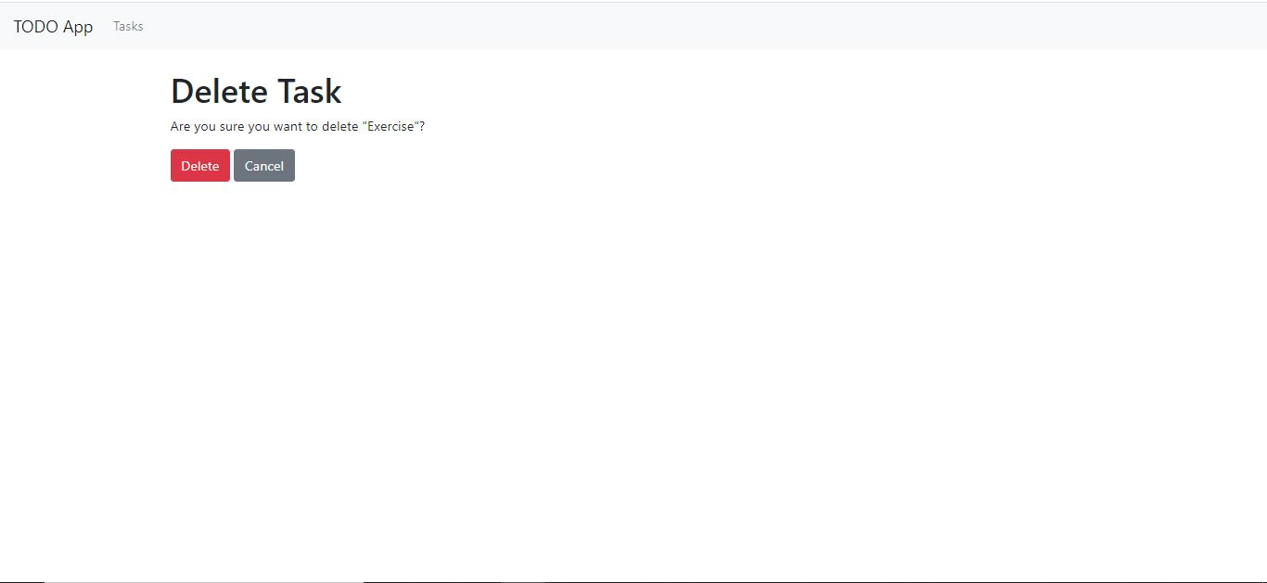

**Admin login:**

Username is “admin” and password is “admin”.

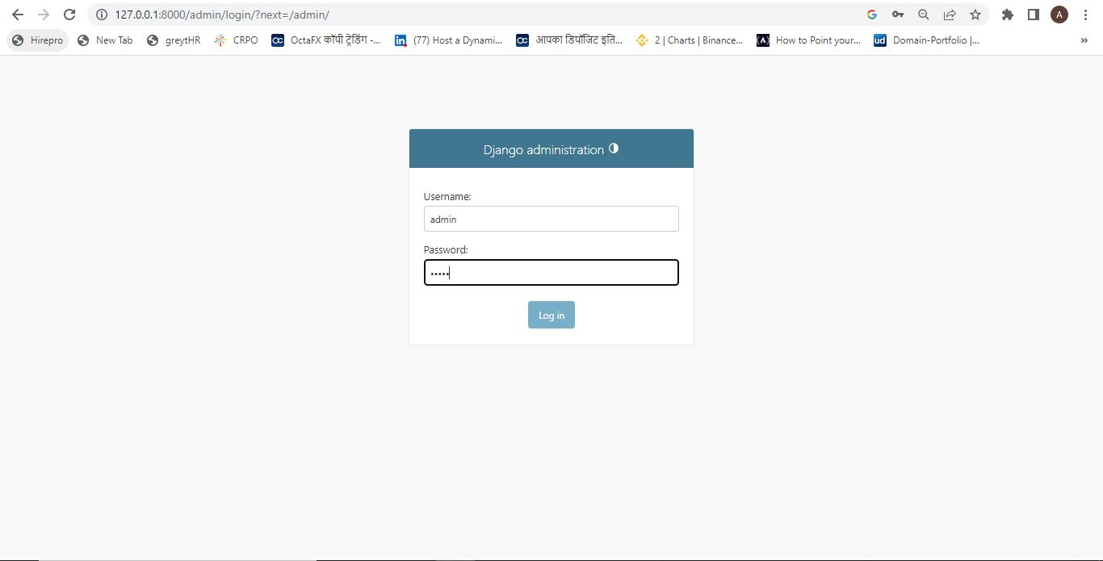

**Backend Database view:**

